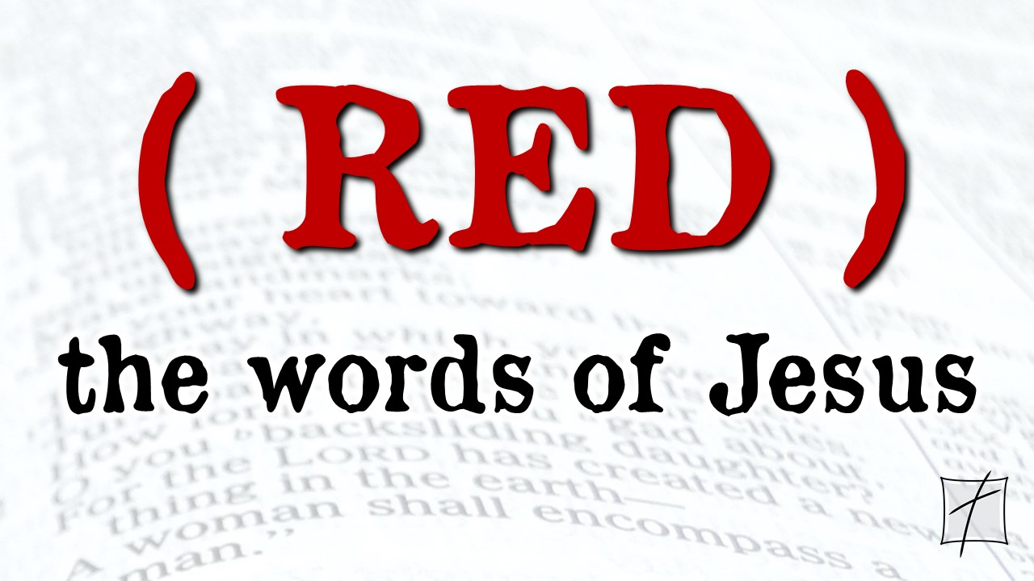
October 18, 2020
Pastor Joseph Britain

When the master of ceremonies tasted the water that was now wine, not knowing where it had come from (though, of course, the servants knew), he called the bridegroom over. “A host always serves the best wine first,” he said. “Then, when everyone has had a lot to drink, he brings out the less expensive wine. But you have kept the best until now!” (John 2:9-10 NLT)

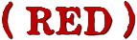
The power of _________
Don’t be afraid! I am the First and the Last. I am the Living One. I died, but look - I am alive forever and ever! And I hold the keys of death and the grave. (Rev 1:17b-18)

We can only live _____________
But God said to him, “You fool! This very night your soul is required of you; and now who will own what you have prepared?” (Luke 12:20)

Now faith is the substance of things hoped for, the evidence of things not seen
(Heb 11:1 KJV)

A ______________ as we get older
How blessed is the man who does not walk in the counsel of the wicked, nor stand in the path of sinners, nor sit in the seat of scoffers! (Ps 1:1)

_________________ is now
Do you not say, ‘It is still four months until the harvest comes?’ Look, I say to you, raise your eyes and look at the fields and see, they are white for harvest. (John 4:35 AMP)

We must work the works of Him who sent Me as long as it is day; night is coming when no one can work. (John 9:4)

Falling in __________ with God is now
But the time is coming - indeed it’s here now - when true worshipers will worship the Father in spirit and in truth. The Father is looking for those who will worship him that way. (John 4:23 NLT)

Time to ______ ____ _________ with God is now
Jesus answered them, “Do you now believe?" (John 16:31)

Jesus said to him, “I am the way, and the truth, and the life; no one comes to the Father but through Me. If you had known Me, you would have known My Father also; from now on you know Him, and have seen Him.” (John 14:6-7)

Until now you have asked nothing in my name. Ask, and you will receive, that your joy may be full. (John 16:24)

All scripture is from the New American Standard Version unless otherwise noted

