May 15, 2022
Pastor Joseph Britain

Consequently, you are no longer foreigners and aliens, but fellow citizens with God’s people and also members of His household, built on the foundation of the apostles and prophets, with Christ Jesus Himself as the Chief Cornerstone. - Eph 2:19-20 NIV

_________________________ and _______________
But as many as received Him, to them He gave the right to become children of God, to those who believe in His name, who were born, not of blood, nor of the will of the flesh, nor of the will of a man, but of God - John 1:12-13

Every child needs a _______________ . . .

And every family needs a __________

Jesus is the Chief ___________________________
Built on the foundation of the apostles and prophets, with Christ Jesus Himself as the Chief Cornerstone. In Him the whole building is joined together and rises to become a holy temple in the Lord. And in Him you too are being built together to become a dwelling in which God lives by His Spirit. - Eph 2:20-22 NIV

Who or what are you _______________________ ?
You also, as living stones, are being built up as a spiritual house for a holy priesthood - 1Pe 2:5a

We are Living _______________
If you use stones to build My altar, use only natural, uncut stones. Do not shape the stones with a tool, for that would make the altar unfit for holy use.
- Ex 20:25 NLT

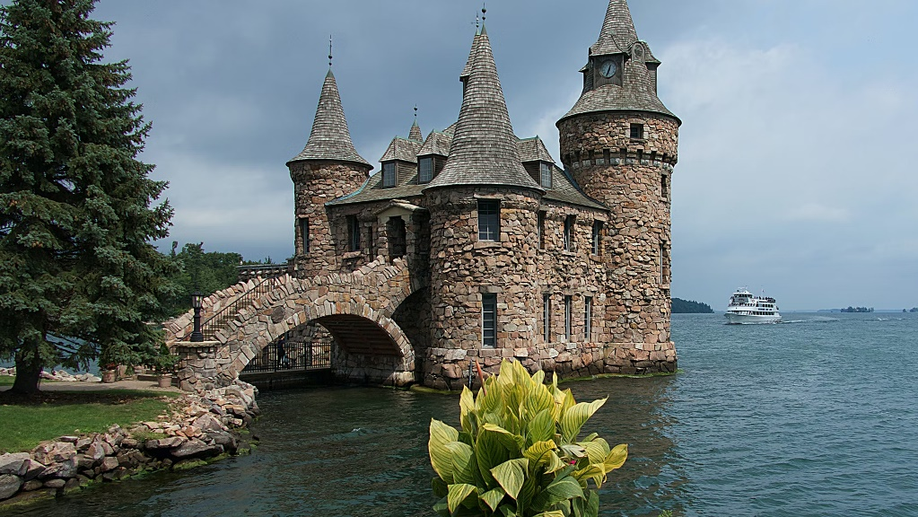

All scripture is from the New American Standard Bible unless otherwise noted

