September 9, 2020
Pastor Joseph Britain

______________ Christianity
Gathering them together, He commanded them not to leave Jerusalem, but to wait for what the Father had promised (Acts 1:4a)

But you will receive power when the Holy Spirit has come upon you; and you shall be My witnesses both in Jerusalem, and in all Judea and Samaria, and even to the remotest part of the earth. (Acts 1:8)

When the day of Pentecost had come, they were all together in one place. And suddenly there came from heaven a noise like a violent rushing wind, and it filled the whole house where they were sitting. And there appeared to them tongues as of fire distributing themselves, and they rested on each one of them. And they were all filled with the Holy Spirit and began to speak with other tongues, as the Spirit was giving them utterance. (Acts 2:1-4)

He said to them, “Did you receive the Holy Spirit when you believed?” And they said to him, “No, we have not even heard whether there is a Holy Spirit.” (Acts 19:2-3)

I thank God, I speak in tongues more than you all (1Cor 14:8)

Builds you ______
But you, beloved, building yourselves up on your most holy faith, praying in the Holy Spirit (Jude 20)

One who speaks in a tongue edifies himself (1 Cor 14:4a)

And the Holy Spirit helps us in our distress. For we don't even know what we should pray for, nor how we should pray. But the Holy Spirit prays for us with groanings (articulate speech) that cannot be expressed in words (known language). And the Father who knows all hearts knows what the Spirit is saying, for the Spirit pleads for us believers in harmony with God's own will. (Rom 8:26-27 NLT)

My _____________ prays
For if I pray in a tongue, my spirit prays, but my mind is unfruitful. (1 Cor 14:14)

For one who speaks in a tongue does not speak to men but to God; for no one understands, but in the Spirit he speaks mysteries. (1 Cor 14:2)

For if I pray in a tongue, my spirit prays, but my mind is unfruitful. What is the outcome then? I will pray with the spirit and I will pray with the mind also; I will sing with the spirit and I will sing with the mind also (1 Cor 14:14-15)

Benefit in __________
I thank God, I speak in tongues more than you all; however, in the church I desire to speak five words with my mind so that I may instruct others also, rather than ten thousand words in a tongue. (1 Cor 14:18-19)

It will be ________
For if I pray in a tongue, my spirit prays (1 Cor 14:14a)

The spirits of prophets are subject to prophets (1 Cor 14:32)

Trust God from the bottom of your heart; don’t try to figure out everything on your own. (Prov 3:5 MSG)

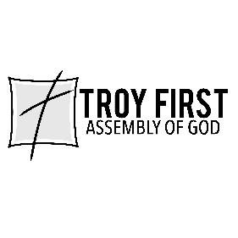

All scripture is from the New American Standard Version unless otherwise noted

