October 14, 2020
Pastor Joseph Britain

But the fruit of the Spirit is love, joy, peace, patience, kindness, goodness, faithfulness, gentleness, self-control; against such things there is no law. (Gal 5:22-23)

________ schools of thought about interpretation

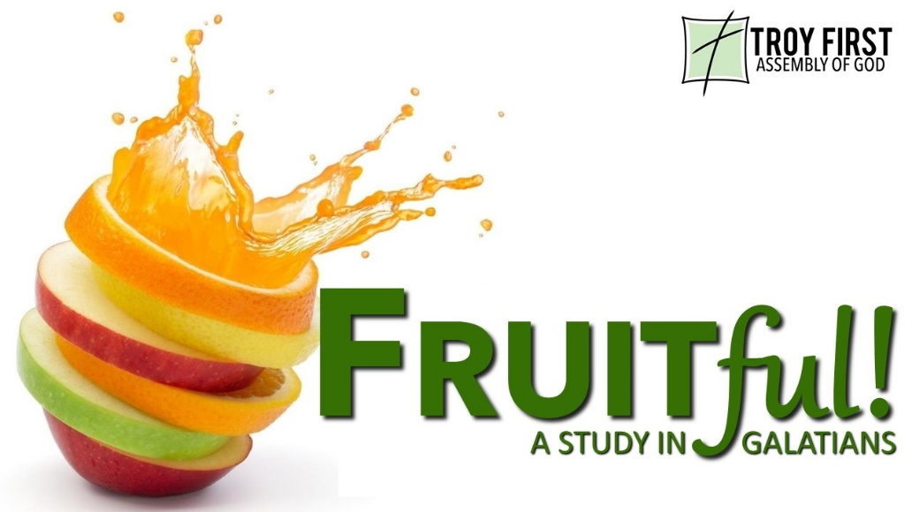

Love isn’t _____________________
You shall love your neighbor as yourself (Mark 12:32b)

A new commandment I give to you, that you love one another, even as I have loved you, that you also love one another. (John 13:34)

Little children, let us not love with word or with tongue, but in deed and truth.
(1John 3:18)

Be devoted to one another in brotherly love; give preference to one another in honor (Rom 12:10)

Knowing _____________ Love only goes so far

You can make an A+ in Bible and still flunk Christianity

Knowledge makes arrogant, but love edifies. (1Cor 8:1b)

Old habits die __________
For it is God who is at work in you, both to will and to work for His good pleasure. (Php 2:13)

But no one can tame the tongue; it is a restless evil and full of deadly poison. (Jas 3:8)

Little children, let us not love with word or with tongue, but in deed and truth.
(1John 3:18)

All scripture is from the New American Standard Version unless otherwise noted

