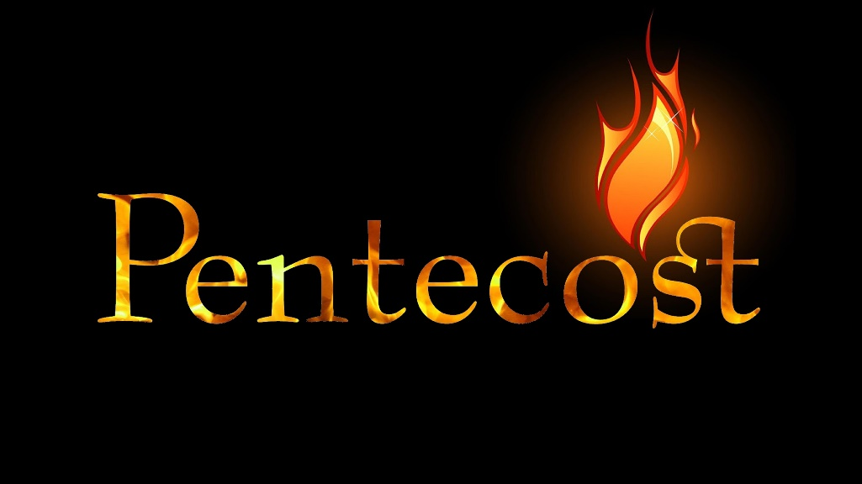

June 8, 2022
Pastor Joseph Britain

The Giving of the ________ at Mount Sinai

The ____________________ to Freedom

A Nation of __________________
And Moses went up to God, and the Lord called to him from the mountain, saying, “This is what you shall say to the house of Jacob and tell the sons of Israel: ‘You yourselves have seen what I did to the Egyptians, and how I carried you on eagles’ wings, and brought you to Myself. Now then, if you will indeed obey My voice and keep My covenant, then you shall be My own possession among all the peoples, for all the earth is Mine; and you shall be to Me a kingdom of priests and a holy nation.’ - Ex 19:3-6a

But you will be called the priests of the Lord; You will be spoken of as ministers of our God. - Is 61:6a

But you are a chosen people, a royal priesthood, a holy nation, a people for God’s own possession, so that you may proclaim the excellencies of Him who has called you out of darkness into His marvelous light; for you once were not a people, but now you are the people of God; you had not received mercy, but now you have received mercy. - 1Pe 2:9-10

To Him who loves us and released us from our sins by His blood - and He made us into a kingdom, priests to His God and Father - to Him be the glory and the dominion forever and ever. Amen. - Rev 1:5b-6

All about the ____________________ of Pentecost
Now these things happened to them as an example, and they were written for our instruction, upon whom the ends of the ages have come. - 1Cor 10:11

Pictures and ____________________

BOTH EVENTS:
• occurred on a mountain
• happened to a newly redeemed people.
• involved God giving a gift
• included God coming in fire
• had similar sounds and symbols
Now Mount Sinai was all in smoke because the Lord descended upon it in fire; and its smoke ascended like the smoke of a furnace, and the entire mountain quaked violently. When the sound of the trumpet grew louder and louder, Moses spoke, and God answered him with thunder. - Ex 19:18-19

And suddenly a noise like a violent rushing wind came from heaven, and it filled the whole house where they were sitting. And tongues that looked like fire appeared to them, distributing themselves, and a tongue rested on each one of them. And they were all filled with the Holy Spirit and began to speak with different tongues, as the Spirit was giving them the ability to speak out. - Acts 2:2-4

SIGNIFICANT DIFFERENCES:
• Sinai had God’s Law written on tablets of stone
Pentecost writes God’s Law in our hearts
• The day the Law was given 3,000 died
The day of Pentecost 3,000 came to life
Not that we are adequate in ourselves so as to consider anything as having come from ourselves, but our adequacy is from God, who also made us adequate as servants of a new covenant, not of the letter but of the Spirit; for the letter kills, but the Spirit gives life. - 2Cor 3:5-6

• The fire at Sinai said, “Stay away”
The fire of Pentecost landed on EACH person’s head

All scripture is from the New American Standard Version unless otherwise noted

