April 24, 2022
Pastor Joseph Britain

Behold, how good and how pleasant it is for brothers to live together in unity! It is like the precious oil on the head, running down upon the beard, as on Aaron’s beard, the oil which ran down upon the edge of his robes. It is like the dew of Hermon coming down upon the mountains of Zion; for the Lord commanded the blessing there - life forever. - Ps 133:1-3

As for me and my house, we will serve the Lord - Josh 24:15b

The Power of ______
Then the Lord said to Moses, “Gather before me seventy men who are recognized as elders and leaders of Israel. Bring them to the Tabernacle to stand there with you. I will come down and talk to you there. I will take some of the Spirit that is upon you, and I will put the Spirit upon them also. They will bear the burden of the people along with you, so you will not have to carry it alone. - Num 11:16-17 NLT

Now all the earth used the same language and the same words. And it came about, as they journeyed east, that they found a plain in the land of Shinar and settled there. Then they said to one another, “Come, let’s make bricks and fire them thoroughly.” And they used brick for stone, and they used tar for mortar. And they said, “Come, let’s build ourselves a city, and a tower whose top will reach into heaven, and let’s make a name for ourselves; otherwise we will be scattered abroad over the face of all the earth.” Now the Lord came down to see the city and the tower which the men had built. And the Lord said, “Behold, they are one people, and they all have the same language. And this is what they have started to do, and now nothing which they plan to do will be impossible for them.” - Gen 11:1-6

I am not asking on behalf of these alone, but also for those who believe in Me through their word, that they may all be one; just as You, Father, are in Me and I in You
- John 17:20-21a

True unity is __________________ and _________
It is like the precious oil on the head, running down upon the beard, as on Aaron’s beard, the oil which ran down upon the edge of his robes. It is like the dew of Hermon coming down upon the mountains of Zion; for the Lord commanded the blessing there - life forever - Ps 133:2-3

All things are permitted, but not all things are of benefit. All things are permitted, but not all things build people up. No one is to seek his own advantage, but rather that of his neighbor. - 1Cor 10:23-24

Unity brings the Commanded _________________
When the Day of Pentecost had fully come, they were all with one accord in one place - Acts 2:1 NKJV

But Peter, taking his stand with the other eleven, raised his voice and declared to them - Acts 2:14a

Your destiny is bigger than ________
For we are God’s masterpiece. He has created us anew in Christ Jesus, so we can do the good things he planned for us long ago - Eph 2:10 NLT

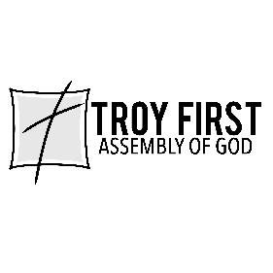

All scripture is from the New American Standard Bible unless otherwise noted

