January 27, 2021
Pastor Joseph Britain

A _______________________ heart

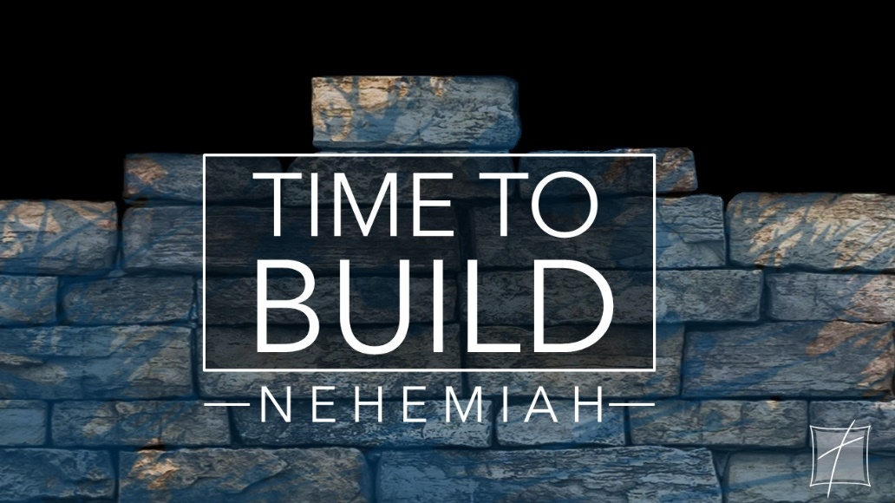

A _______________ spirit
Now when I heard these words (the report of the City of God in ruins), I sat down and wept and mourned for days; and I was fasting and praying before the God of heaven. (Ne 1:4)

God always wants to work ______ you

before He works _________________ you
Now may the God of peace... equip you in every good thing to do His will, working in us that which is pleasing in His sight, through Jesus Christ (Heb 13:20a&21a)

God always stands against the ____________

God always responds to the _________________
God is opposed to the proud, but gives grace to the humble. (Jas 4:6b)

The Lord mocks the mockers but is gracious to the humble (Prov 3:34 NLT)

Having a __________ view of God

and an ____________________ view of ourself

Nehemiah’s _______________
Let Your ear now be attentive and Your eyes open, to hear the prayer of Your servant which I am praying before You now, day and night, on behalf of the sons of Israel Your servants, confessing the sins of the sons of Israel which we have committed against You; I and my father’s house have sinned. (Ne 1:6)

We are much better at being busy for God
than we are at being with God

Do we truly believe that we can accomplish more on our knees
than we can with our hands and feet?

Our confidence must be in His ________________
Remember, please, the word which You commanded Your servant Moses, saying, ‘If you are unfaithful, I will scatter you among the peoples; but if you return to Me and keep My commandments and do them, though those of you who have been scattered were in the most remote part of the heavens, I will gather them from there and bring them to the place where I have chosen to have My name dwell.’ (Ne 1:8-9)

They are Your servants and Your people whom You redeemed by Your great power and by Your strong hand. (Ne 1:10)

Next Steps
• Let's pray and ask God to give us a dislocated heart and a broken,
contrite spirit
• Let's allow God to work IN us - so He can then work THRU us
• Let's root out any PRIDE that might be lurking in our heart or our mind
• Let's cultivate a HIGH view of God thru some time spent in real WORSHIP
• Let's spend more time WITH God than we do working FOR God
• Let's remember that the task, the calling, the destiny is built on His PROMISE,
not our abilities

