October 28, 2020
Pastor Joseph Britain

But the fruit of the Spirit is love, joy, peace, patience, kindness, goodness, faithfulness, gentleness, self-control; against such things there is no law. (Gal 5:22-23)

The original ____________ word - eiréné
When Uriah came to him, David asked concerning the welfare of Joab and the people and the state of the war. (2Sam 11:7)

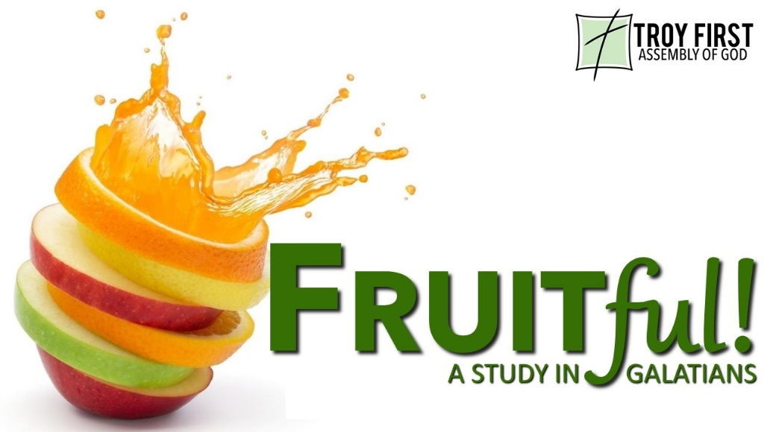

____________ Peace to _______________
Let the peace of Christ rule in your hearts (Col 3:15a)

Peace follows _____________
. . . having made peace through the blood of His cross (Col 1:20b)

I give eternal life to them, and they will never perish; and no one will snatch them out of My hand (John 10:28)

We are to __________ in Peace
Be angry and yet do not sin (Eph 4:26a)

If possible, so far as it depends on you, be at peace with all men. (Rom 12:18)

Manage the _______________
“And it shall be in the last days,” God says, “That I will pour forth of My Spirit on all mankind; and your sons and your daughters shall prophesy, and your young men shall see visions, and your old men shall dream dreams” (Acts 2:17)

A cheerful heart has a continual feast (Prov 15:15b)

Peace in the _____________
Be anxious for nothing, but in everything by prayer and supplication with thanksgiving let your requests be made known to God. And the peace of God, which surpasses all comprehension, will guard your hearts and your minds in Christ Jesus. (Php 4:6-7)

All scripture is from the New American Standard Version unless otherwise noted

