

November 21, 2021
Pastor Joseph Britain

The hand of the Lord was upon me, and He brought me out by the Spirit of the Lord and set me down in the middle of the valley; and it was full of bones. He had me pass among them all around, and behold, there were very many on the surface of the valley; and behold, they were very dry. Then He said to me, “Son of man, can these bones live?” And I answered, “Lord God, You Yourself know.” Again He said to me, “Prophesy over these bones and say to them, ‘You dry bones, hear the word of the Lord.’ This is what the Lord God says to these bones: ‘Behold, I am going to make breath enter you so that you may come to life. And I will attach tendons to you, make flesh grow back on you, cover you with skin, and put breath in you so that you may come to life; and you will know that I am the Lord.’” So I prophesied as I was commanded; and as I prophesied, there was a loud noise, and behold, a rattling; and the bones came together, bone to its bone. And I looked, and behold, tendons were on them, and flesh grew and skin covered them; but there was no breath in them. Then He said to me, “Prophesy to the breath, prophesy, son of man, and say to the breath, ‘The Lord God says this: “Come from the four winds, breath, and breathe on these slain, so that they come to life.”’” So I prophesied as He commanded me, and the breath entered them, and they came to life and stood on their feet, an exceedingly great army. - Eze 37:1-10


A ________ place
He had me pass among them all around, and behold, there were very many on the surface of the valley; and behold, they were very dry. - Eze 37:2

God has the _______________________________
Then He said to me, “Son of man, can these bones live?” And I answered, “Lord God, You Yourself know.” - Eze 37:3

God supplies the ____________
Again He said to me, “Prophesy over these bones and say to them, ‘You dry bones, hear the word of the Lord.’ This is what the Lord God says to these bones: ‘Behold, I am going to make breath enter you so that you may come to life.
- Eze 37:4-5

God supplies the ______________________

God supplies the ____________/__________________
And I will attach tendons to you, make flesh grow back on you, cover you with skin, and put breath in you so that you may come to life; and you will know that I am the Lord.’” - Eze 37:6

I will put flesh and muscles on you and cover you with skin. I will put breath into you, and you will come to life. Then you will know that I am the Lord.’” - Eze 37:6 NLT

It’s time to ______________ again
Our present sufferings are not worth comparing with the glory that will be revealed in us - Rom 8:18b

Is it a __________ . . . or a ____________________?
So I prophesied as He commanded me, and the breath entered them, and they came to life and stood on their feet, an exceedingly great army. - Eze 37:1-10

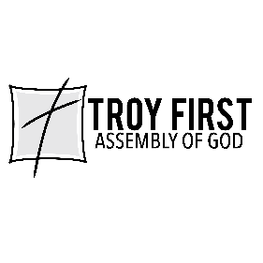

All scripture is from the New American Standard Bible unless otherwise noted

