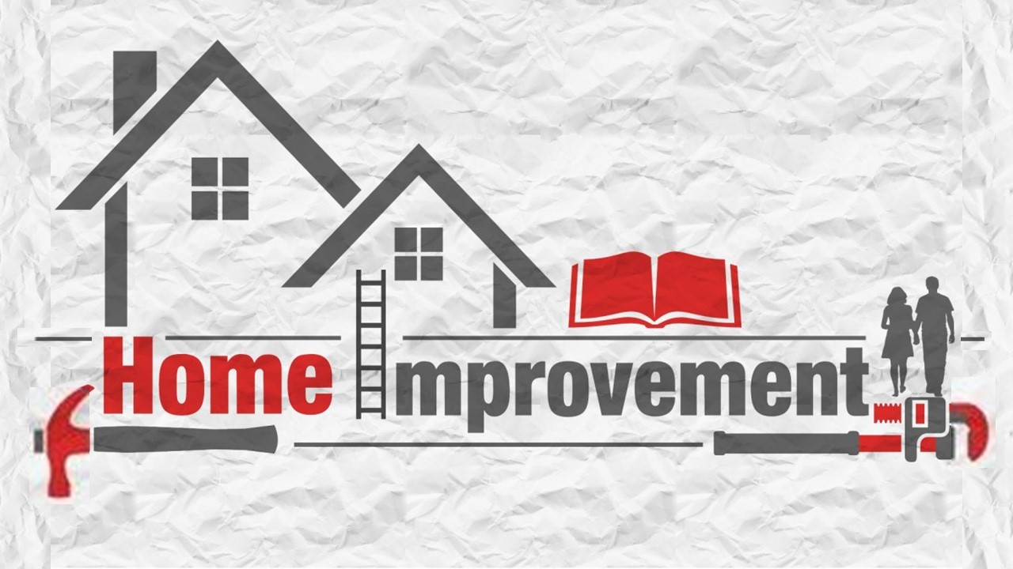
August 9, 2020
Pastor Joseph Britain

____________ your father and mother
Honor your father and your mother, that your days may be prolonged in the land which the Lord your God gives you. (Ex 20:12)

Honor your father and mother (which is the first commandment with a promise), so that it may be well with you, and that you may live long on the earth. (Eph 6:2-3)

______________ them
Listen to your father, who gave you life, and don’t despise your mother when she is old. (Prov 23:22 NLT)

______________________ them
Every one of you shall reverence his mother and his father, and you shall keep My sabbaths; I am the Lord your God. (Lev 19:3)

______________ them
Do not withhold good from those to whom it is due, when it is in your power to do it. (Prov 19:27)

Don’t ________________ them
Honor widows who are widows indeed; but if any widow has children or grandchildren, they must first learn to practice piety in regard to their own family and to make some return to their parents; for this is acceptable in the sight of God.
(1Tim 5:3-4)

(Jesus speaking to Mary and Joseph) “But why did you need to search?” He asked. “Didn’t you know that I must be about my Father’s work?” But they didn’t understand what He meant. Then He returned to Nazareth with them and was obedient to them. (Luke 2:49-51a NLT)

We should strive to parent like _______

God _______________
Call to Me and I will answer you, and I will tell you great and mighty things, which you do not know. (Jer 33:3)

Be anxious for nothing, but in everything by prayer and supplication with thanksgiving let your requests be made known to God. (Php 4:6)

It will also come to pass that before they call, I will answer; and while they are still speaking, I will hear. (Is 65:24)

God ______________________ us
By wisdom a house is built, and by understanding it is established (Prov 24:3)

God ___________ His promises
God is not a man, that He should lie, nor a son of man, that He should repent; Has He said, and will He not do it? (Num 23:19)

God gives us _______________ and ______________
And have you completely forgotten this word of encouragement that addresses you as a father addresses his son? It says, “My son, do not make light of the Lord’s discipline, and do not lose heart when He rebukes you, because the Lord disciplines the one He loves, and He chastens everyone He accepts as His son.” Endure hardship as discipline; God is treating you as His children. For what children are not disciplined by their father? If you are not disciplined - and everyone undergoes discipline - then you are not legitimate, not true sons and daughters at all. Moreover, we have all had human fathers who disciplined us and we respected them for it. How much more should we submit to the Father of spirits and live! (Heb 12:5-9)

God give us roots, wings and __________
“For I know the plans that I have for you,” declares the Lord, “plans for welfare and not for calamity to give you a future and a hope.” (Jer 29:11)

For we are His workmanship, created in Christ Jesus for good works, which God prepared beforehand so that we would walk in them. (Eph 2:10)

All scripture is from the New American Standard Version unless otherwise noted

