June 6, 2021
Pastor Joseph Britain

God knows __________
Great is our Lord and abundant in strength; His understanding is infinite
(Ps 147:5)

God’s Word can’t help us if we refuse to _________
And all these blessings shall come on thee, and overtake thee, if thou shalt hearken unto the voice of the Lord thy God (Deut 28:2 KJV)

There is a way which seemeth right unto a man, but the end thereof are the ways of death (Prov 14:12 KJV)

I surrender _______
Therefore let all the house of Israel know for certain that God has made Him both Lord and Christ (Acts 2:36a)

And as they were eating, He said, “Truly I say to you that one of you will betray Me.” Being deeply grieved, they began saying to Him, each one: “Surely it is not I, Lord?”
And Judas, who was betraying Him, said, “Surely it is not I, Rabbi?” Jesus said to him, “You have said it yourself.” (Matt 26:21-22 & 25)

Now why do you call Me, ‘Lord, Lord,’ and do not do what I say? (Luke 6:46)

Lordship = ______________ and Blessing
If you fully obey (listen to) the Lord your God and carefully keep all His commands that I am giving you today, the Lord your God will set you high above all the nations of the world. You will experience all these blessings if you obey the Lord your God: Your towns and your fields will be blessed. Your children and your crops will be blessed. The offspring of your herds and flocks will be blessed. Your fruit baskets and breadboards will be blessed. Wherever you go and whatever you do, you will be blessed. The Lord will conquer your enemies when they attack you. They will attack you from one direction, but they will scatter from you in seven! The Lord will guarantee a blessing on everything you do and will fill your storehouses with grain. The Lord your God will bless you in the land He is giving you. If you obey the commands of the Lord your God and walk in his ways, the Lord will establish you as his holy people as He swore He would do. Then all the nations of the world will see that you are a people claimed by the Lord, and they will stand in awe of you. The Lord will give you prosperity in the land He swore to your ancestors to give you, blessing you with many children, numerous livestock, and abundant crops. The Lord will send rain at the proper time from his rich treasury in the heavens and will bless all the work you do. You will lend to many nations, but you will never need to borrow from them. If you listen to these commands of the Lord your God that I am giving you today, and if you carefully obey them, the Lord will make you the head and not the tail, and you will always be on top and never at the bottom. (Deut 28:1-13 NLT)

That’s not how I do it – then ____________
Sanctify them in the truth; Your word is truth (John 17:17)

You will know the truth, and the truth will set you free (John 8:32)

Don’t copy the behavior and customs of this world, but let God transform you into a new person by changing the way you think. Then you will learn to know God’s will for you, which is good and pleasing and perfect. (Rom 12:2 NLT)

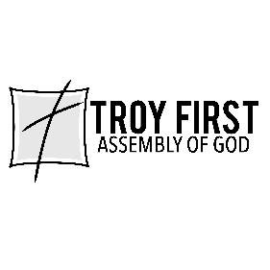

All scripture is from the New American Standard Version unless otherwise noted

