March 6, 2022
Pastor Joseph Britain

And forgive us our debts, as we also have forgiven our debtors - Matt 6:12

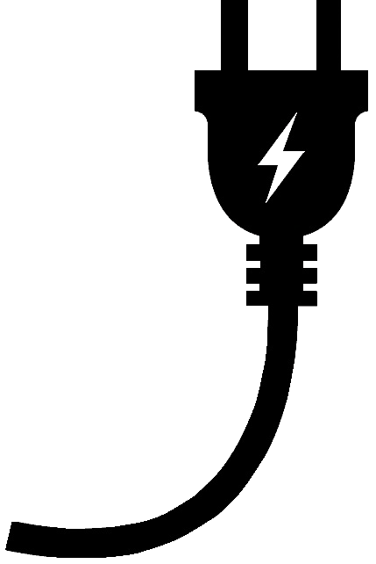

Just what is a __________?

. . . ______ we forgive . . .

The point – the word __________________

It’s a big deal because of ______________________
For if you forgive other people for their offenses, your heavenly Father will also forgive you. But if you do not forgive other people, then your Father will not forgive your offenses.
- Matt 6:14-15

Then Peter came up and said to Him, “Lord, how many times shall my brother sin against me and I still forgive him? Up to seven times?” Jesus said to him, “I do not say to you, up to seven times, but up to seventy times seven times. “For this reason the kingdom of heaven is like a king who wanted to settle accounts with his slaves. And when he had begun to settle them, one who owed him ten thousand talents was brought to him. But since he did not have the means to repay, his master commanded that he be sold, along with his wife and children and all that he had, and repayment be made. So the slave fell to the ground and prostrated himself before him, saying, ‘Have patience with me and I will repay you everything.’ And the master of that slave felt compassion, and he released him and forgave him the debt. But that slave went out and found one of his fellow slaves who owed him a hundred denarii; and he seized him and began to choke him, saying, ‘Pay back what you owe!’ So his fellow slave fell to the ground and began to plead with him, saying, ‘Have patience with me and I will repay you.’ But he was unwilling, and went and threw him in prison until he would pay back what was owed. So when his fellow slaves saw what had happened, they were deeply grieved and came and reported to their master all that had happened. Then summoning him, his master said to him, ‘You wicked slave, I forgave you all that debt because you pleaded with me. Should you not also have had mercy on your fellow slave, in the same way that I had mercy on you?’ And his master, moved with anger, handed him over to the torturers until he would repay all that was owed him. My heavenly Father will also do the same to you, if each of you does not forgive his brother from your heart.” - Matt 18:21-15

We can’t carry the __________________
where God wants to take us
Be angry, and yet do not sin; do not let the sun go down on your anger - Eph 4:26

Be not hasty in thy spirit to be angry: for anger resteth in the bosom of fools
- Ecc 7:9 KJV

All scripture is from the New International Version unless otherwise noted

