April 25, 2021
Pastor Joseph Britain

A Giant is anything that stands between you
and the promises of God that feels impossible to overcome

Your Giant is here for a ________________ reason
Dear friends, don’t be surprised at the fiery trials you are going through, as if something strange were happening to you (1Pe 4:12 NLT)

Yet in all these things we are more than conquerors through Him who loved us
(Rom 8:37 NKJV)

Discover and hold onto the _____________ of God
Lord, strengthen my inner being by the promises of your Word (Ps 119:116a)

This Book of the Law shall not depart from your mouth, but you shall meditate on it day and night, so that you may be careful to do according to all that is written in it; for then you will make your way prosperous, and then you will achieve success. (Josh 1:8)

You will know the truth, and the truth will set you free (John 8:32)

The Lord is the portion of my inheritance and my cup; You support my lot. The measuring lines have fallen for me in pleasant places; Indeed, my inheritance is beautiful to me (Ps 16:5-6)

When we believe a lie - we _____________ the liar
The entrance of Your words gives light (Ps 119:130a NKJV)

You will know the truth, and the truth will set you free (John 8:32)

Our weapons ______________ the strongholds
For the weapons of our warfare are not of the flesh but have divine power to destroy strongholds. We destroy arguments and every lofty opinion raised against the knowledge of God, and take every thought captive to obey Christ (2Cor 10:4-5 ESV)

We’ve been given a __________-_________ sword
For the word of God is living and active, and sharper than any two-edged sword (Heb 4:12a)

My people are destroyed for lack of knowledge (Hos 4:6a)

Yet in all these things we are more than conquerors through Him who loved us
(Rom 8:37 NKJV)

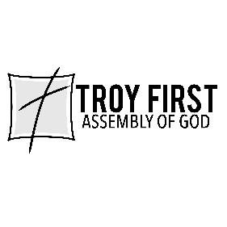

All scripture is from the New American Standard Version unless otherwise noted

