September 15, 2021
Pastor Joseph Britain

Is my hurt __________ _____________________ ?
Who can say, “I have cleansed my heart, I am pure from my sin”? (Prov 20:9)

The foolishness of a person ruins his way, and his heart rages against the Lord.
(Prov 19:3)

A scoffer seeks wisdom and finds none (Prov 14:6a)

Is my hurt because of someone else’s _______ ?
The heart knows its own bitterness, and a stranger does not share its joy. (Prov 14:10)

A brother who is offended is harder to be won than a strong city, and quarrels are like the bars of a citadel. (Prov 18:19)

Hatred stirs up strife, but love covers all offenses. (Prov 10:12)

Like a bad tooth and an unsteady foot is confidence in a treacherous person in time of trouble (Prov 25:19)

What powerful __________ am I believing?
A truthful witness saves lives, but one who declares lies is deceitful
(Prov 14:25)

You will know the truth, and the truth will set you free (John 8:32)

Get the truth and never sell it (Prov 23:23a NLT)

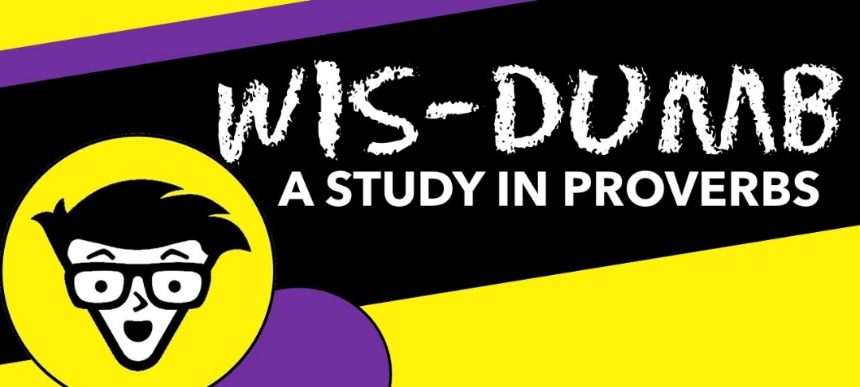

Am I living with a _____________ or broken spirit?
A joyful heart is good medicine, but a broken spirit dries up the bones (Prov 17:22)

(Jesus speaking) Whoever drinks of the water that I will give him shall never be thirsty; but the water that I will give him will become in him a fountain of water springing up to eternal life.” (John 4:14)

Do I trust God enough to go _________ way?
There is a way which seems right to a person, but its end is the way of death (Prov 14:12)

One with a wayward heart will have his fill of his own ways, but a good person will be satisfied with his. (Prov 14:14)

Afterward, Jesus found him in the temple and said to him, “Behold, you have become well; do not sin anymore, so that nothing worse happens to you.” (John 5:14)

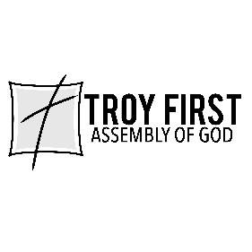

All scripture is from the New American Standard Version unless otherwise

