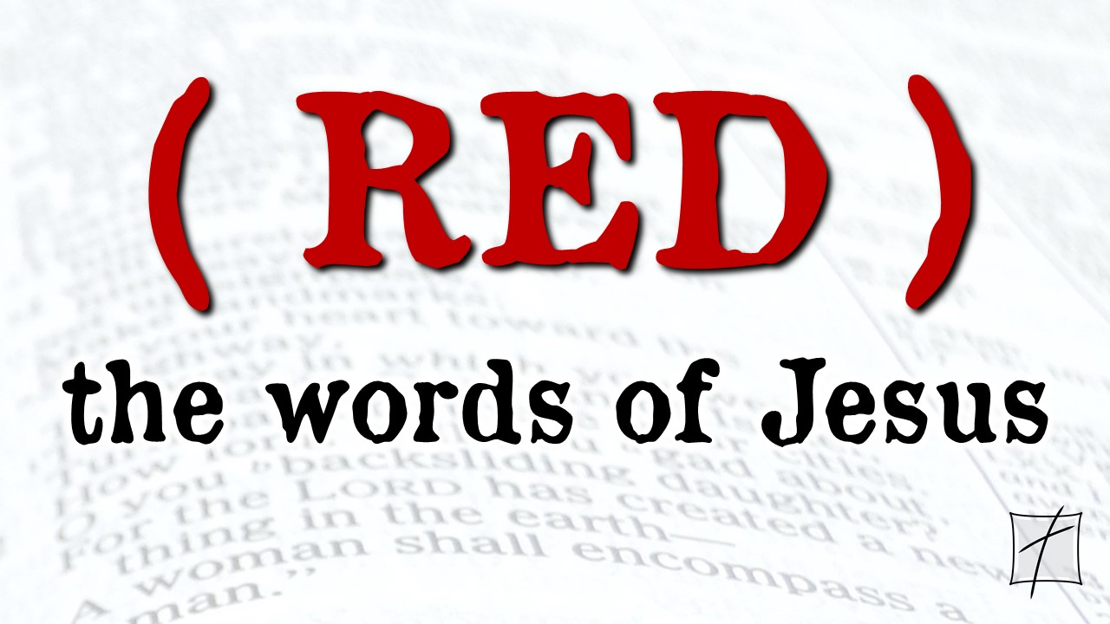
November 15, 2020
Pastor Joseph Britain

____________ stories - ________ point
Yet later, the other virgins also came, saying, “Lord, Lord, open up for us.” But He answered, “Truly I say to you, I do not know you.” (Matt 25:11-12)

Master, I knew you to be a hard man, reaping where you did not sow, and gathering where you did not scatter seed. And I was afraid, so I went away and hid your talent in the ground. See, you still have what is yours. (Matt 25:24b-25)

But when the Son of Man comes in His glory, and all the angels with Him, then He will sit on His glorious throne. And all the nations will be gathered before Him; and He will separate them from one another, just as the shepherd separates the sheep from the goats; and He will put the sheep on His right, but the goats on the left. Then the King will say to those on His right, “Come, you who are blessed of My Father, inherit the kingdom prepared for you from the foundation of the world. For I was hungry, and you gave Me something to eat; I was thirsty, and you gave Me something to drink; I was a stranger, and you invited Me in; naked, and you clothed Me; I was sick, and you visited Me; I was in prison, and you came to Me.” Then the righteous will answer Him, “Lord, when did we see You hungry, and feed You, or thirsty, and give You something to drink? And when did we see You as a stranger, and invite You in, or naked, and clothe You? And when did we see You sick, or in prison, and come to You?” And the King will answer and say to them, “Truly I say to you, to the extent that you did it for one of the least of these brothers or sisters of Mine, you did it for Me.” Then He will also say to those on His left, “Depart from Me, you accursed people, into the eternal fire which has been prepared for the devil and his angels; for I was hungry, and you gave Me nothing to eat; I was thirsty, and you gave Me nothing to drink; I was a stranger, and you did not invite Me in; naked, and you did not clothe Me; sick, and in prison, and you did not visit Me.” Then they themselves also will answer, “Lord, when did we see You hungry, or thirsty, or as a stranger, or naked, or sick, or in prison, and did not take care of You?” Then He will answer them, “Truly I say to you, to the extent that you did not do it for one of the least of these, you did not do it for Me, either.” These will go away into eternal punishment, but the righteous into eternal life. (Matt 25:31-46)

Only ________ options

Neither side ________________ Jesus at the time

Not just _____________________ - it’s Jesus
Truly I say to you, to the extent that you did it for one of the least of these brothers or sisters of Mine, you did it for Me. (Matt 25:40b)

Many of our pioneers are already __________
When you give to someone in need, don’t do as the hypocrites do - blowing trumpets in the synagogues and streets to call attention to their acts of charity! I tell you the truth, they have received all the reward they will ever get. But when you give to someone in need, don’t let your left hand know what your right hand is doing. Give your gifts in private, and your Father, who sees everything, will reward you. (Matt 6:2-4 NLT)

Not about the church - it’s about ______
And He said, “Truly I say to you, this poor widow put in more than all of them” (Luke 21:3)

What if I get ____________?
Therefore, my dear brothers and sisters, stand firm. Let nothing move you. Always give yourselves fully to the work of the Lord, because you know that your labor in the Lord is not in vain. (1Cor 15:58)

_____________
So for one who knows the right thing to do and does not do it, for him it is sin. (Jas 4:17)

Be someone else’s _________________

I declare that I will live as a healer. I am sensitive to the needs of those around me.
I will lift the fallen, restore the broken, and encourage the discouraged.
I am full of compassion and kindness. I won't just look for a miracle; I will become
someone's miracle by showing God's love and mercy everywhere I go.
This is my declaration.
(Joel Osteen from I Declare - 31 Promises to Speak Over Your Life)

