August 18, 2021
Pastor Joseph Britain

Our God is _____________
This is the message we have heard from Him and announce to you, that God is Light, and in Him there is no darkness at all. If we say that we have fellowship with Him and yet walk in the darkness, we lie and do not practice the truth; but if we walk in the Light as He Himself is in the Light, we have fellowship with one another, and the blood of Jesus His Son cleanses us from all sin (1John 1:5-7)

God’s __________ brings light
The unfolding of Your words gives light; It gives understanding to the simple.(Ps 119:130)

What do we _____ with the light?
Those who disregard discipline despise themselves, but the one who heeds correction gains understanding (Prov 15:32 NIV)

For the commandment is a lamp and the teaching is light; and rebukes for discipline are the way of life (Prov 6:23)

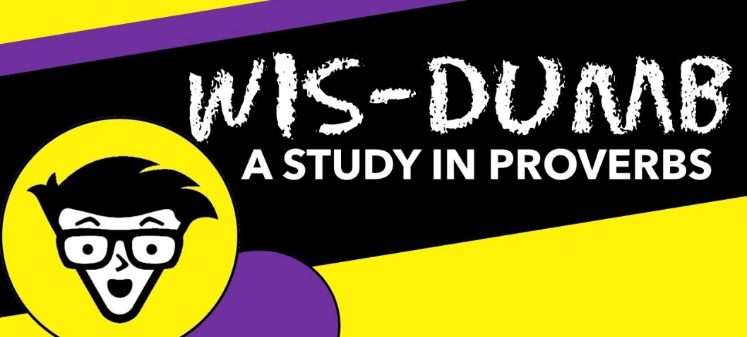
All Scripture is inspired by God and beneficial for teaching, for rebuke, for correction, for training in righteousness; so that the man or woman of God may be fully capable, equipped for every good work (2Tim 3:16-17)

Three typical _______________________

DEFEND – DISMISS – DEFLECT

Do not be wise in your own estimation (Rom 12:16b)

Those who disregard discipline despise themselves, but the one who heeds correction gains understanding (Prov 15:32 NIV)

Do not rebuke a scoffer, or he will hate you; Rebuke a wise person and he will love you (Prov 9:8)

Do not correct a scoffer [who foolishly ridicules and takes no responsibility for his error] or he will hate you; Correct a wise man [who learns from his error], and he will love you. (Prov 9:8 AMP)

How a __________ person responds
The wise are glad to be instructed, but babbling fools fall flat on their faces (Prov 10:8 NLT)

Fools have no interest in understanding; they only want to air their own opinions. (Prov 18:2 NLT)

Three ____________________ of the wise

SHOW ME - TEACH ME - HELP ME

Show me the way I should go, for to you I entrust my life (Ps 143:8b)

Make me know Your ways, Lord; Teach me Your paths. Lead me in Your truth and teach me, for You are the God of my salvation (Ps 25:4-5a)

For the Lord corrects those He loves, just as a father corrects a child in whom He delights (Prov 3:12 NLT)

May the righteous strike me with mercy and discipline me; It is oil for the head; My head shall not refuse it (Ps 141:5a)

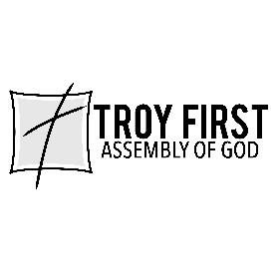

All scripture is from the New American Standard Version unless otherwise noted

