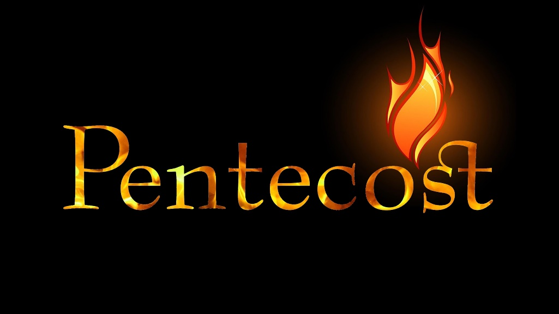

June 1, 2022
Pastor Joseph Britain

The Feast of _____________

The Feast of Shavuot (Weeks)

You shall also count for yourselves from the day after the Sabbath, from the day when you brought in the sheaf of the wave offering; there shall be seven complete Sabbaths. You shall count fifty days to the day after the seventh Sabbath; then you shall present a new grain offering to the Lord. You shall bring in from your dwelling places two loaves of bread as a wave offering, made of two-tenths of an ephah; they shall be of a fine flour, baked with leaven as first fruits to the Lord. - Lev 23:15-17

Pentecost means 50th - Shavuot means Weeks

So what are we ___________________________ /

___________________________ ?

Harvest - Giving of the Law at Mount Sinai

He shall wave the sheaf before the Lord for you to be accepted; on the day after the Sabbath the priest shall wave it… Until this very day, until you have brought in the offering of your God, you shall eat neither bread nor roasted grain nor new produce. It is to be a permanent statute throughout your generations in all your dwelling places. – Lev 23:11 & 14

But the fact is, Christ has been raised from the dead, the first fruits of those who are asleep. – 1Cor 15:20

You shall count fifty days to the day after the seventh Sabbath; then you shall present a new grain offering to the Lord. You shall bring in from your dwelling places two loaves of bread as a wave offering, made of two-tenths of an ephah; they shall be of a fine flour, baked with leaven as first fruits to the Lord. - Lev 23:16-17

A Feast about the __________________
(Jesus speaking) “But you will receive power when the Holy Spirit has come upon you; and you shall be My witnesses both in Jerusalem and in all Judea, and Samaria, and as far as the remotest part of the earth.” – Acts 1:8

The ______________________ of the Gentiles
He (God) says, “It is too small a thing that You (talking to Messiah) should be my Servant to raise up the tribes of Jacob and to restore the protected ones of Israel; I will also make You a light of the nations so that My salvation may reach to the end of the earth.” – Is 49:6

What God has cleansed, no longer consider it unholy - Acts 10:15b

But when Cephas (Peter) came to Antioch, I opposed him to his face, because he stood condemned. For prior to the coming of some men from James, he used to eat with the Gentiles; but when they came, he began to withdraw and separate himself, fearing those from the circumcision. The rest of the Jews joined him in hypocrisy, with the result that even Barnabas was carried away by their hypocrisy. – Gal 2:11-13

Flawless ___________________ not a pre-requisite
In the first month, on the fourteenth day of the month at evening, you shall eat unleavened bread, until the twenty-first day of the month at evening. For seven days there shall be no dough with yeast found in your houses; for whoever eats anything with yeast, that person shall be cut off from the congregation of Israel, whether he is a stranger or a native of the land. You shall not eat anything with yeast; in all your dwellings you shall eat unleavened bread. - Ex 12:18-20

For seven days you shall eat unleavened bread, but on the first day you shall remove dough with yeast from your houses; for whoever eats anything with yeast from the first day until the seventh day, that person shall be cut off from Israel. - Ex 12:15

And they were all filled with the Holy Spirit - Acts 2:4a

What shall we say then? Are we to continue in sin so that grace may increase? Far from it! - Rom 6:1-2a

But we have this treasure in earthen containers, so that the extraordinary greatness of the power will be of God and not from ourselves - 2Cor 4:7

