April 11, 2021
Pastor Joseph Britain

_______________________ of a Giant

A Giant is anything that stands between you
and the promises of God that feels impossible to overcome

The thief comes only to steal and kill and destroy; I came so that they would have life, and have it abundantly (John 10:10)

No, in all these things we are more than conquerors through him who loved us
(Rom 8:37 NIV)

Jesus said, “The things that are impossible with people are possible with God.”
(Luke 18:27)

_________________________ there is a Giant
As he (David) was speaking with them (his brothers), behold, the champion, the Philistine from Gath named Goliath, was coming up from the army of the Philistines, and he spoke these same words; and David heard him (1Sam 17:23)

Apart from Me you can do nothing (John 15:5b)

__________________ what victory would look like
Then David said to the men who were standing by him, “What will be done for the man who kills this Philistine and rids Israel of the disgrace?” (1Sam 17:26a)
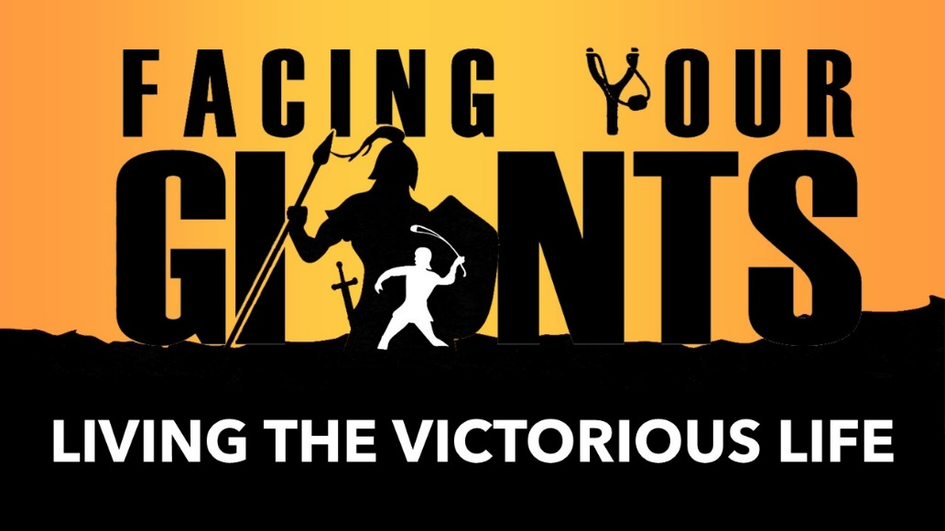

______________ your thinking
And David said, “The Lord who saved me from the paw of the lion and the paw of the bear, He will save me from the hand of this Philistine.” (1Sam 17:37)

For those who are in accord with the flesh set their minds on the things of the flesh, but those who are in accord with the Spirit, the things of the Spirit. For the mind set on the flesh is death, but the mind set on the Spirit is life and peace (Rom 8:5-6)

With God inside you, take ______________
But David said to the Philistine, “You come to me with a sword, a spear, and a saber, but I come to you in the name of the Lord of armies, the God of the armies of Israel, whom you have defied. This day the Lord will hand you over to me, and I will strike you and remove your head from you. Then I will give the dead bodies of the army of the Philistines this day to the birds of the sky and the wild animals of the earth, so that all the earth may know that there is a God in Israel, and that this entire assembly may know that the Lord does not save by sword or by spear; for the battle is the Lord’s, and He will hand you over to us!” (1Sam 17:45-47)

It was for freedom that Christ set us free; therefore keep standing firm and do not be subject again to a yoke of slavery (Gal 5:1)

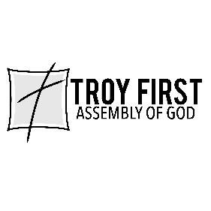

All scripture is from the New American Standard Version unless otherwise noted

