November 11, 2020
Pastor Joseph Britain

But the fruit of the Spirit is love, joy, peace, patience, kindness, goodness, faithfulness, gentleness, self-control; against such things there is no law. (Gal 5:22-23)

The fruit are more than good __________________

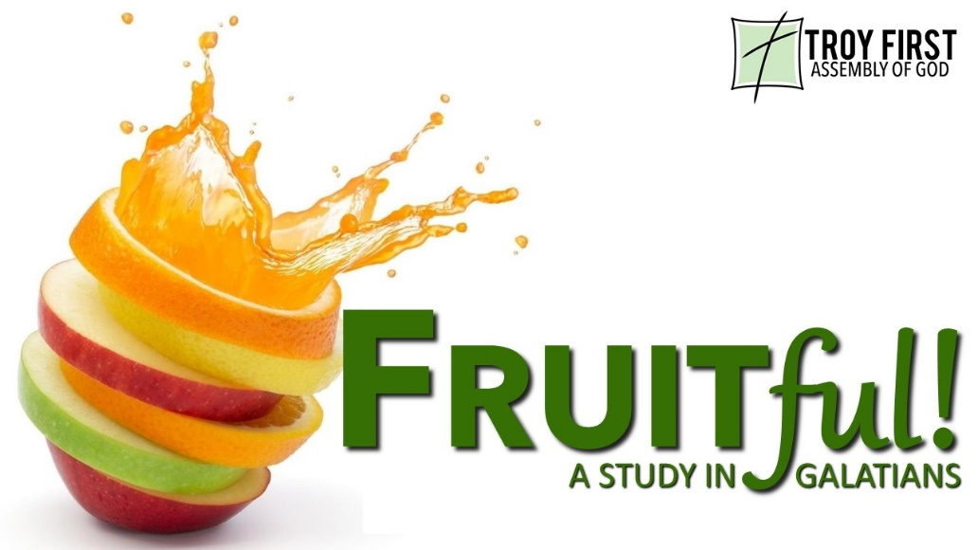

Fruit is sweet and ___________________

Fruit is about _______ attributes

The original ___________ word - chrestos
The kindness of God leads you to repentance (Rom 2:4b)

You have tasted the kindness of the Lord (1Pe 2:3b)

So that in the ages to come He might show the boundless riches of His grace in kindness toward us in Christ Jesus (Eph 2:7)

Kindness begins _____ ___________

Kindness ____________

Hostile or ____________ people are not kind

______________________ people are not kind
I wrote something to the church; but Diotrephes, who loves to be first among them, does not accept what we say. For this reason, if I come, I will call attention to his deeds which he does, unjustly accusing us with malicious words; and not satisfied with this, he himself does not receive the brothers either, and he forbids those who want to do so and puts them out of the church. (3John 1:9-10)

__________________ are not kind

______________ ______________ __________ people
are not kind

Kind people truly ______

Kind people ________ ____________

_________ vs ________________
But the greatest of you shall be your servant. (Matt 23:11)

All scripture is from the New American Standard Version unless otherwise noted

