September 6, 2020
Pastor Joseph Britain
FORGIVENESS

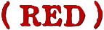
Aphiemi (Forgive) is an ________________ term

Jesus forgives when He __________________
When they came to the place called The Skull, there they crucified Him and the criminals, one on the right and the other on the left. But Jesus was saying, “Father, forgive them; for they do not know what they are doing.” (Luke 23:33-34a)

“You have heard the law that says, ‘Love your neighbor’ and hate your enemy. But I say, love your enemies! Pray for those who persecute you! In that way, you will be acting as true children of your Father in heaven.” (Matt 5:43-45a)

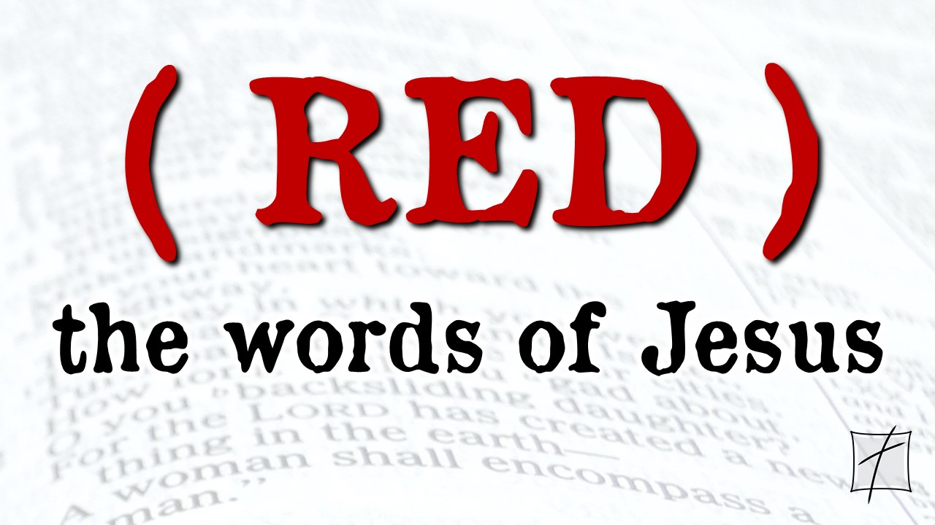

Jesus forgives _______
For this reason the kingdom of heaven may be compared to a king who wished to settle accounts with his slaves. When he had begun to settle them, one who owed him ten thousand talents was brought to him. But since he did not have the means to repay, his lord commanded him to be sold, along with his wife and children and all that he had, and repayment to be made. So the slave fell to the ground and prostrated himself before him, saying, ‘Have patience with me and I will repay you everything.’ And the lord of that slave felt compassion and released him and forgave him the debt.
(Matt 18:23-27)

Straightening up, Jesus said to her, “Woman, where are they? Did no one condemn you?” She said, “No one, Lord.” And Jesus said, “I do not condemn you, either. Go. From now on sin no more.” (John 8:10-11)

Jesus always __________________
Then He said to her, “Your sins have been forgiven.” (Luke 7:48)

And Jesus seeing their faith said to the paralytic, “Son, your sins are forgiven.”
(Mark 2:5)

“For this reason the kingdom of heaven may be compared to a king who wished to settle accounts with his slaves.” (Matt 18:23)

“So he got up and came to his father. But while he was still a long way off, his father saw him and felt compassion for him, and ran and embraced him and kissed him. And the son said to him, ‘Father, I have sinned against heaven and in your sight; I am no longer worthy to be called your son.’ But the father said to his slaves, ‘Quickly bring out the best robe and put it on him, and put a ring on his hand and sandals on his feet; and bring the fattened calf, kill it, and let us eat and celebrate; for this son of mine was dead and has come to life again; he was lost and has been found.’ And they began to celebrate.” (Luke 15:20-24)

Forgiveness demands _____________
Jesus said, “I do not condemn you, either. Go. From now on sin no more.” (John 8:11b)

Afterward Jesus found him in the temple and said to him, “Behold, you have become well; do not sin anymore, so that nothing worse happens to you.” (John 5:14)

I _________ forgive
“And forgive us our debts, as we also have forgiven our debtors.” (Matt 6:12)

“For if you forgive others for their transgressions, your heavenly Father will also forgive you. But if you do not forgive others, then your Father will not forgive your transgressions.” (Matt 6:14-15)

“And the lord of that slave felt compassion and released him and forgave him the debt. But that slave went out and found one of his fellow slaves who owed him a hundred denarii (the equivalent of 4 months of work); and he seized him and began to choke him, saying, ‘Pay back what you owe.’ So his fellow slave fell to the ground and began to plead with him, saying, ‘Have patience with me and I will repay you.’ But he was unwilling and went and threw him in prison until he should pay back what was owed. So when his fellow slaves saw what had happened, they were deeply grieved and came and reported to their lord all that had happened. Then summoning him, his lord said to him, ‘You wicked slave, I forgave you all that debt because you pleaded with me. Should you not also have had mercy on your fellow slave, in the same way that I had mercy on you?’ And his lord, moved with anger, handed him over to the torturers until he should repay all that was owed him. My heavenly Father will also do the same to you, if each of you does not forgive his brother from your heart.” (Matt 18:27-35)

All scripture is from the New American Standard Version unless otherwise noted

