June 20, 2021
Pastor Joseph Britain

You will know the truth and the truth will set you free (John 8:32)

Get free from __________

Borrower is ______________ to the lender
The rich rules over the poor, and the borrower becomes the lender’s slave
(Prov 22:7)

(Jesus speaking) No one can serve two masters (Matt 6:24a)

The _______________ Fundamental
A prudent person foresees danger and takes precautions. The simpleton goes blindly on and suffers the consequences. (Prov 22:3)

How do I get out? . . . ___________!
Save yourself like a gazelle escaping from a hunter, like a bird fleeing from a net
(Prov 6:5)

Imagine ______ debt
Remember this - a farmer who plants only a few seeds will get a small crop. But the one who plants generously will get a generous crop. You must each decide in your heart how much to give. And don’t give reluctantly or in response to pressure. “For God loves a person who gives cheerfully.” And God will generously provide all you need. Then you will always have everything you need and plenty left over to share with others. As the Scriptures say, “They share freely and give generously to the poor. Their good deeds will be remembered forever.” For God is the one who provides seed for the farmer and then bread to eat. In the same way, He will provide and increase your resources and then produce a great harvest of generosity in you. Yes, you will be enriched in every way so that you can always be generous. (2Cor 9:6-11a NLT)

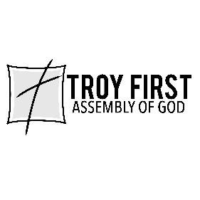

All scripture is from the New American Standard Version unless otherwise noted

