January 20, 2021
Pastor Joseph Britain

God’s plan _______ your life –

is bigger __________ your life!
For we are God’s masterpiece. He has created us anew in Christ Jesus, so we can do the good things he planned for us long ago. (Eph 2:10 NLT)

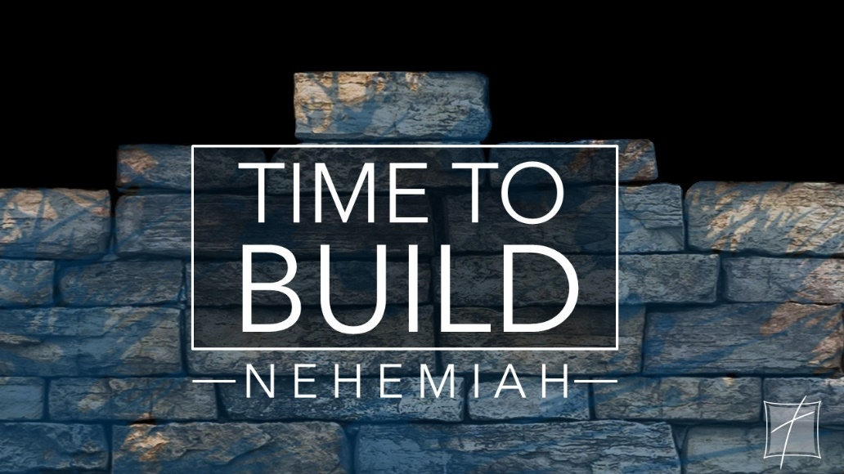

God wants to throw _________________ behind you
For the eyes of the Lord roam throughout the earth, so that He may strongly support those whose heart is completely His. (2Chron 16:9a)

A ________________________ heart
The words of Nehemiah the son of Hacaliah. Now it happened in the month Chislev, in the twentieth year, while I was in Susa the capitol, that Hanani, one of my brothers, and some men from Judah came; and I asked them about the Jews who had escaped and had survived the captivity, and about Jerusalem. And they said to me, “The remnant there in the province who survived the captivity are in great distress and disgrace, and the wall of Jerusalem is broken down and its gates have been burned with fire.” Now when I heard these words, I sat down and wept and mourned for days; and I was fasting and praying before the God of heaven. (Ne 1:1-4)

A holy ____________________

_______________________ your holy discontent
Now it came about, when the king (David) lived in his house, and the Lord had given him rest on every side from all his enemies, that the king said to Nathan the prophet, “See now, I live in a house of cedar, but the ark of God remains within the tent.” Nathan said to the king, “Go, do all that is in your mind, for the Lord is with you.” (2Sam 7:1-3)

All scripture is from the New American Standard Version unless otherwise noted

