February 17, 2021
Pastor Joseph Britain

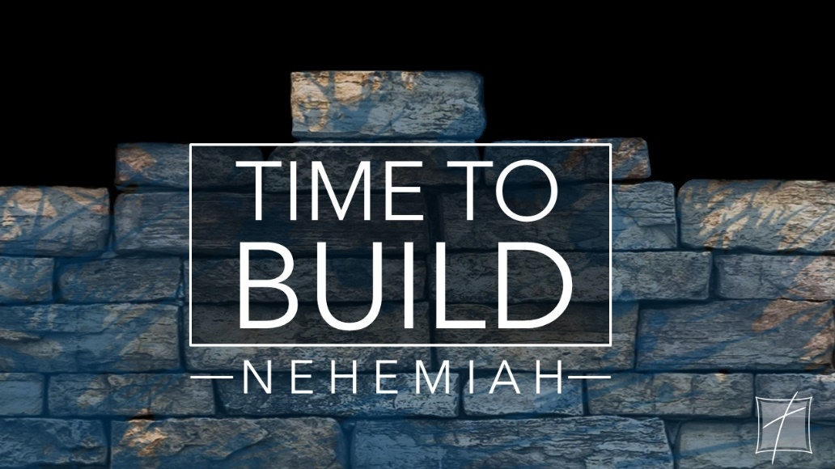
A personal ________________________

Strong commitment ________________ others
Then I said to them, “You see the bad situation we are in, that Jerusalem is desolate and its gates have been burned by fire. Come, let’s rebuild the wall of Jerusalem so that we will no longer be a disgrace.” And I told them how the hand of my God had been favorable to me and also about the king’s words which he had spoken to me. Then they said, “Let’s arise and build.” So they put their hands to the good work. (Ne 2:17-18)

Now the sons of Hassenaah built the Fish Gate; they laid its beams and installed its doors with its bolts and bars. Next to them Meremoth the son of Uriah the son of Hakkoz made repairs. And next to him Meshullam the son of Berechiah the son of Meshezabel made repairs. And next to him Zadok the son of Baana also made repairs. Moreover, next to him the Tekoites made repairs, but their nobles did not support the work of their masters. Now Joiada the son of Paseah and Meshullam the son of Besodeiah repaired the Ancient Gate; they laid its beams and installed its doors with its bolts and its bars. Next to them Melatiah the Gibeonite and Jadon the Meronothite, the men of Gibeon and of Mizpah, also made repairs for the official seat of the governor of the province beyond the Euphrates River. Next to him Uzziel the son of Harhaiah of the goldsmiths made repairs. And next to him Hananiah, one of the perfumers, made repairs, and they restored Jerusalem as far as the Broad Wall. And next to them Rephaiah the son of Hur, the official of half the district of Jerusalem, made repairs. Next to them Jedaiah the son of Harumaph made repairs opposite his house. And next to him Hattush the son of Hashabneiah made repairs. Malchijah the son of Harim and Hasshub the son of Pahath-moab repaired another section and the Tower of Furnaces.

Next to him Shallum the son of Hallohesh, the official of half the district of Jerusalem, made repairs, he and his daughters. Hanun and the inhabitants of Zanoah repaired the Valley Gate. They built it and installed its doors with its bolts and its bars, and a thousand cubits of the wall to the Dung Gate. And Malchijah the son of Rechab, the official of the district of Beth-haccherem repaired the Dung Gate. He built it and installed its doors with its bolts and its bars. (Ne 3:3-14)

Strong commitment demands our __________
But whatever things were gain to me, these things I have counted as loss because of Christ. More than that, I count all things to be loss in view of the surpassing value of knowing Christ Jesus my Lord, for whom I have suffered the loss of all things, and count them mere rubbish, so that I may gain Christ, and may be found in Him, not having a righteousness of my own derived from the Law, but that which is through faith in Christ, the righteousness which comes from God on the basis of faith, that I may know Him and the power of His resurrection and the fellowship of His sufferings, being conformed to His death; if somehow I may attain to the resurrection from the dead. Not that I have already grasped it all or have already become perfect, but I press on if I may also take hold of that for which I was even taken hold of by Christ Jesus. Brothers and sisters, I do not regard myself as having taken hold of it yet; but one thing I do: forgetting what lies behind and reaching forward to what lies ahead, I press on toward the goal for the prize of the upward call of God in Christ Jesus. (Php 3:7-14)

All scripture is from the New American Standard Version unless otherwise noted

