December 23, 2020
Pastor Joseph Britain

Understanding the ____________
But I say, walk by the Spirit, and you will not carry out the desire of the flesh. For the desire of the flesh is against the Spirit, and the Spirit against the flesh; for these are in opposition to one another, in order to keep you from doing whatever you want. But if you are led by the Spirit, you are not under the Law. Now the deeds of the flesh are evident, which are: sexual immorality, impurity, indecent behavior, idolatry, witchcraft, hostilities, strife, jealousy, outbursts of anger, selfish ambition, dissensions, factions, envy, drunkenness, carousing, and things like these, of which I forewarn you, just as I have forewarned you, that those who practice such things will not inherit the kingdom of God. But the fruit of the Spirit is love, joy, peace, patience, kindness, goodness, faithfulness, gentleness, self-control; against such things there is no law. Now those who belong to Christ Jesus crucified the flesh with its passions and desires. If we live by the Spirit, let’s follow the Spirit as well. Let’s not become boastful, challenging one another, envying one another. (Gal 5:16-26)
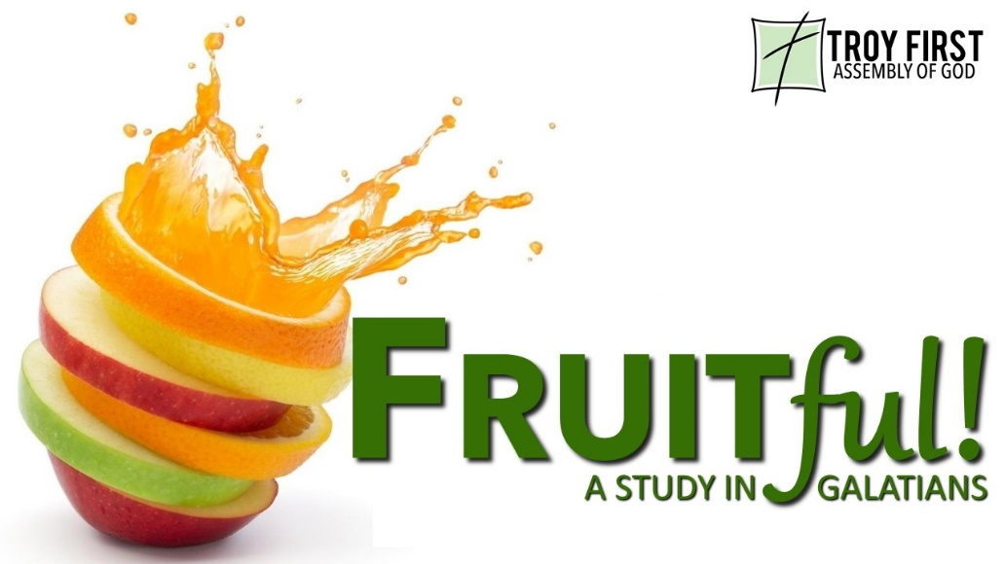

The 15 ____________ of the Flesh

________________ Sin
Now the deeds of the flesh are evident, which are: sexual immorality, impurity, indecent behavior, (Gal 5:19)

Wrongful _____________________ Experiences
… Idolatry, witchcraft… (Gal 5:20a)

Violations of Brotherly ___________
... Hostilities, strife, jealousy, outbursts of anger, selfish ambition, dissensions, factions, envy... (Gal 5:20b-21a)

Unbridled ____________________
… Drunkenness, carousing… (Gal 5:21b)

A Look ________________

The Only _______________
Now those who belong to Christ Jesus crucified the flesh with its passions and desires. If we live by the Spirit, let’s follow the Spirit as well. (Gal 5:24-25)

So you too, consider yourselves to be dead to sin, but alive to God in Christ Jesus. (Rom 6:11)

Knowing this, that our old self was crucified with Him, in order that our body of sin might be done away with, so that we would no longer be slaves to sin; for the one who has died is freed from sin. (Rom 6:6-7)

Make Choices That Please HIM

If we live by the Spirit, let’s follow the Spirit as well. (Gal 5:25)

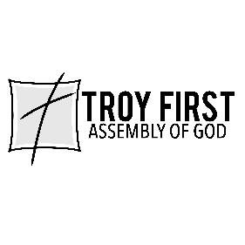

All scripture is from the New American Standard Version unless otherwise noted

