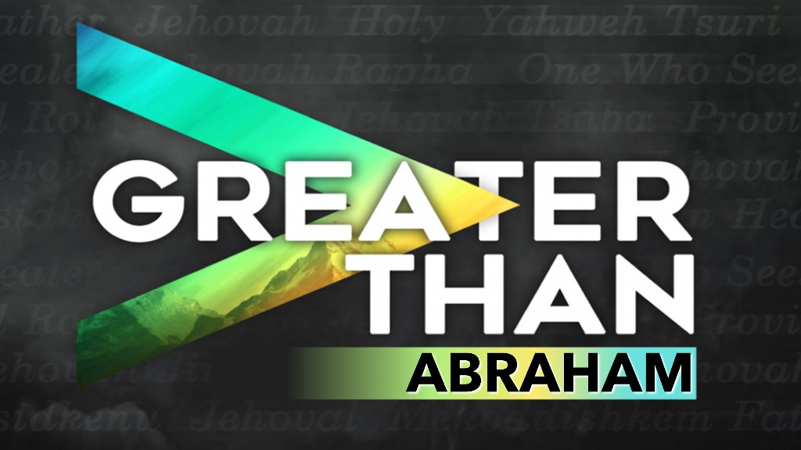

January 5, 2022
Pastor Joseph Britain

Jesus is ____________ and __________ Abraham
Jesus said to them, “Truly, truly I say to you, before Abraham was born, I am.” - John 8:58

The Jews said to Him, “Now we know that You have a demon. Abraham died, and the prophets as well; and yet You say, ‘If anyone follows My word, he will never taste of death.’ You are not greater than our father Abraham, who died, are You? The prophets died too. Whom do You make Yourself out to be?” - John 8:52-53

“The kingdom of the world has become the kingdom of our Lord and of His Christ; and He will reign forever and ever.” - Rev 11:15b

Abraham _____ great faith

Jesus is the ________ and ___________ of our faith
Then he (Abram) believed in the Lord; and He credited it to him as righteousness.
- Gen 15:6

For what does the Scripture say? “Abraham believed God, and it was credited to him as righteousness.” - Rom 4:3

Looking only at Jesus, the Originator and Perfecter of the faith - Heb 12:2a

Abraham left ________ and ____________

Jesus left His _______, _______ and set aside His ______
Now the Lord said to Abram, “Go from your country, and from your relatives and from your father’s house, to the land which I will show you” - Gen 12:1

For I have come down from heaven, not to do My own will, but the will of Him who sent Me - John 6:38

Have this attitude in yourselves which was also in Christ Jesus, who, as He already existed in the form of God, did not consider equality with God something to be grasped, but emptied Himself by taking the form of a bond-servant and being born in the likeness of men - Php 2:6-7

Abraham was God’s ___________

Jesus _____ God
The Scripture was fulfilled which says, “And Abraham believed God, and it was credited to him as righteousness,” and he was called a friend of God - Jas 2:23

“I and the Father are one” - John 10:30

No one has ever seen God. But the unique One, who is himself God, is near to the Father’s heart. He has revealed God to us - John 1:18 NLT6-7

Abraham was ______________ to sacrifice

Jesus ______ our sacrifice
He said, “Do not reach out your hand against the boy, and do not do anything to him; for now I know that you fear God, since you have not withheld your son, your only son, from Me.” - Gen 22:12

Knowing that you were not redeemed with perishable things like silver or gold from your futile way of life inherited from your forefathers, but with precious blood, as of a lamb unblemished and spotless, the blood of Christ - 1Pe 1:18-19

Abraham ______________ Melchizedek

Jesus ____ Melchizedek
For this Melchizedek, king of Salem, priest of the Most High God, who met Abraham as he was returning from the slaughter of the kings and blessed him, to whom also Abraham apportioned a tenth of all the spoils, was first of all, by the translation of his name, king of righteousness, and then also king of Salem, which is king of peace. Without father, without mother, without genealogy, having neither beginning of days nor end of life, but made like the Son of God, he remains a priest perpetually. Now observe how great this man was to whom Abraham, the patriarch, gave a tenth of the choicest spoils. And those indeed of the sons of Levi who receive the priest’s office have a commandment in the Law to collect a tenth from the people, that is, from their countrymen, although they are descended from Abraham. But the one whose genealogy is not traced from them collected a tenth from Abraham and blessed the one who had the promises. But without any dispute the lesser person is blessed by the greater. In this case mortal men receive tithes, but in that case one receives them, of whom it is witnessed that he lives on. And, so to speak, through Abraham even Levi, who received tithes, has paid tithes, for he was still in the loins of his forefather when Melchizedek met him. - Heb 7:1-10

Abraham’s blood was ____________

Jesus’ blood is ________________
(John the Baptist speaking to Pharisees) Therefore produce fruits that are consistent with repentance, and do not start saying to yourselves, ‘We have Abraham as our father,’ for I say to you that from these stones God is able to raise up children for Abraham - Luke 3:8

All scripture is from the New American Standard Bible unless otherwise noted

