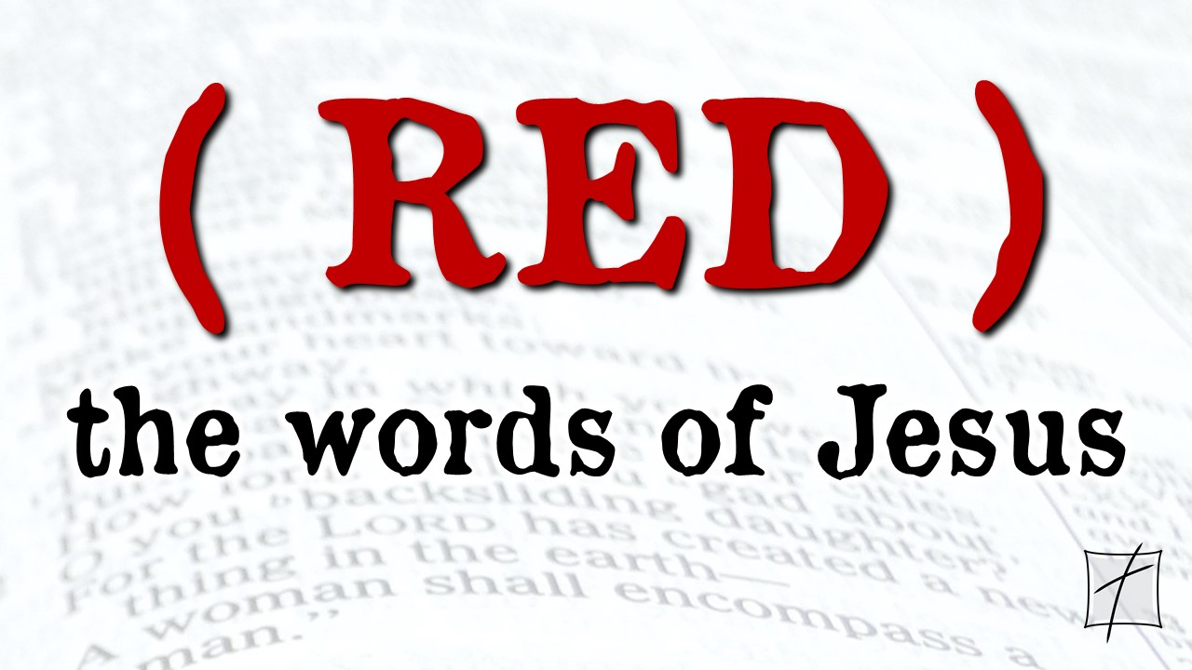
November 8, 2020
Pastor Joseph Britain

______________ in plain sight
But Mary was standing outside the tomb, weeping; so as she wept, she stooped to look into the tomb; and she saw two angels in white sitting, one at the head and one at the feet, where the body of Jesus had been lying. And they said to her, “Woman, why are you weeping?” She said to them, “Because they have taken away my Lord, and I do not know where they put Him.” When she had said this, she turned around and saw Jesus standing there, and yet she did not know that it was Jesus. Jesus said to her, “Woman, why are you weeping? Whom are you seeking?” Thinking that He was the gardener, she said to Him, “Sir, if you have carried Him away, tell me where you put Him, and I will take Him away.” Jesus said to her, “Mary!” She turned and said to Him in Hebrew, “Rabboni!” (which means, Teacher). (John 20:11-16)

Now when the headwaiter tasted the water which had become wine, and did not know where it came from (but the servants who had drawn the water knew) (John 2:9a)

Just because we don’t ________ Him –

Doesn’t mean He isn’t _____________ _____________
About three o’clock in the morning Jesus came toward them, walking on the water. When the disciples saw Him walking on the water, they were terrified. In their fear, they cried out, “It’s a ghost!” But Jesus spoke to them at once. “Don’t be afraid,” He said. “Take courage. I am here!” (Matt 14:25-27 NLT)

And just as they were telling about it, Jesus Himself was suddenly standing there among them. “Peace be with you,” He said. But the whole group was startled and frightened, thinking they were seeing a ghost! “Why are you frightened?” He asked. “Why are your hearts filled with doubt? Look at my hands. Look at my feet. You can see that it’s really me. Touch me and make sure that I am not a ghost, because ghosts don’t have bodies, as you see that I do.” As He spoke, He showed them His hands and His feet. Still they stood there in disbelief, filled with joy and wonder. Then He asked them, “Do you have anything here to eat?” They gave Him a piece of broiled fish, and He ate it as they watched.
(Luke 24:36-43 NLT)

God’s _________ is the lens we need to see
That same day two of Jesus’ followers were walking to the village of Emmaus, seven miles from Jerusalem. As they walked along they were talking about everything that had happened. As they talked and discussed these things, Jesus Himself suddenly came and began walking with them. But God kept them from recognizing Him. He asked them, “What are you discussing so intently as you walk along?” They stopped short, sadness written across their faces. Then one of them, Cleopas, replied, “You must be the only person in Jerusalem who hasn’t heard about all the things that have happened there the last few days.” “What things?” Jesus asked. “The things that happened to Jesus, the man from Nazareth,” they said. “He was a prophet who did powerful miracles, and He was a mighty teacher in the eyes of God and all the people. But our leading priests and other religious leaders handed Him over to be condemned to death, and they crucified Him. We had hoped He was the Messiah who had come to rescue Israel. This all happened three days ago. Then some women from our group of His followers were at His tomb early this morning, and they came back with an amazing report. They said His body was missing, and they had seen angels who told them Jesus is alive! Some of our men ran out to see, and sure enough, His body was gone, just as the women had said.” Then Jesus said to them, “You foolish people! You find it so hard to believe all that the prophets wrote in the Scriptures. Wasn’t it clearly predicted that the Messiah would have to suffer all these things before entering His glory?” Then Jesus took them through the writings of Moses and all the prophets, explaining from all the Scriptures the things concerning Himself. By this time they were nearing Emmaus and the end of their journey. Jesus acted as if He were going on, but they begged Him, “Stay the night with us, since it is getting late.” So He went home with them. As they sat down to eat, He took the bread and blessed it. Then He broke it and gave it to them. Suddenly, their eyes were opened, and they recognized Him. And at that moment he disappeared! They said to each other, “Didn’t our hearts burn within us as He talked with us on the road and explained the Scriptures to us?” (Luke 24:13-32 NLT)

Sometimes we see and hear –

and STILL _________ Him
Therefore when Jesus had received the sour wine, He said, “It is finished!” And He bowed His head and gave up His spirit. (John 19:30)

God __________ giving us the Kingdom
Do not be afraid, little flock, for your Father has chosen gladly to give you the kingdom
(Luke 12:32)

Now He called the twelve together and gave them power and authority over all the demons, and the power to heal diseases. And He sent them out to proclaim the kingdom of God and to perform healing. (Luke 9:1-2)

But seek first His kingdom and His righteousness, and all these things will be provided to you (Matt 6:33)

For the Kingdom of God is not just a lot of talk; it is living by God’s power (1Cor 4:20 NLT)

For the kingdom of God is not eating and drinking, but righteousness and peace and joy in the Holy Spirit (Rom 14:17)

