May 2, 2021
Pastor Joseph Britain

A Giant is anything that stands between you
and the promises of God that feels impossible to overcome

“Arise, set out, and pass through the Valley of Arnon. Look! I have handed over to you Sihon the Amorite, king of Heshbon, and his land; start taking possession and plunge into battle with him. This day I will begin to put the dread and fear of you upon the faces of people everywhere, who, when they hear the news of you, will tremble and be in anguish because of you.” (Deut 2:24-25)

“So I sent messengers from the wilderness of Kedemoth to Sihon king of Heshbon with words of peace, saying, ‘Let me pass through your land; I will travel only on the road. I will not turn aside to the right or to the left. You will sell me food for money so that I may eat, and give me water for money so that I may drink, only let me pass through on foot (Deut 2:26-28)

God says, “Do ____________”

- not “Do ________________”
But Sihon king of Heshbon was not willing for us to pass through his land; for the Lord your God hardened his spirit and made his heart obstinate, in order to hand him over to you, as he is today. (Deut 2:30)

No, in all these things we are more than conquerors through Him who loved us (Rom 8:37 NIV)

Become acutely aware that God is _________ you
Moses said to God, “Who am I, that I should go to Pharaoh, and that I should bring the sons of Israel out of Egypt?” And He said, “Assuredly I will be with you
(Ex 3:11-12a)

No one will be able to oppose you all the days of your life. Just as I have been with Moses, I will be with you; I will not desert you nor abandon you (Josh 1:5)

Have I not commanded you? Be strong and courageous! Do not be terrified nor dismayed, for the Lord your God is with you wherever you go.” (Josh 1:9)

Even though I walk through the valley of the shadow of death, I fear no evil, for You are with me (Ps 23:4a)

What then shall we say to these things? If God is for us, who can be against us?
(Rom 8:31 NKJV)

Do not fear, for I am with you; Do not be afraid, for I am your God. I will strengthen you, I will also help you, I will also uphold you with My righteous right hand (Is 41:10)

Your secret weapon is ________________
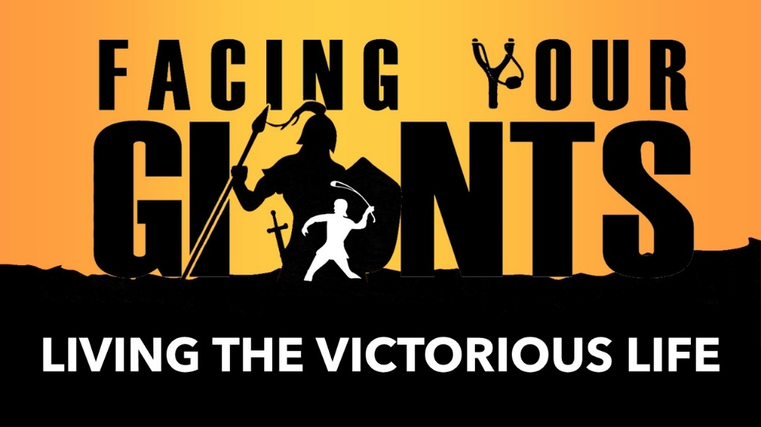
And after singing a hymn, they went out to the Mount of Olives (Matt 26:30)

• Worship ushers in the manifest ________________ of God
You are holy, You who are enthroned upon the praises of Israel (Ps 22:3)

• Worship alters the _______________________
When the trumpeters and the singers were to make themselves heard with one voice to praise and to glorify the Lord, and when they raised their voices accompanied by trumpets, cymbals, and other musical instruments, and when they praised the Lord saying, “He indeed is good for His kindness is everlasting,” then the house, the house of the Lord, was filled with a cloud, so that the priests could not rise to minister because of the cloud, for the glory of the Lord filled the house of God
(2Chron 5:13b-14)

• Worship alters what we can ________
O, magnify the Lord with me, and let us exalt His name together (Ps 34:3 NKJV)

Let God arise, Let His enemies be scattered (Ps 68:1a NKJV)

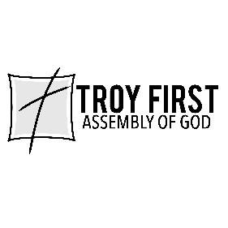
All scripture is from the New American Standard Version unless otherwise noted

