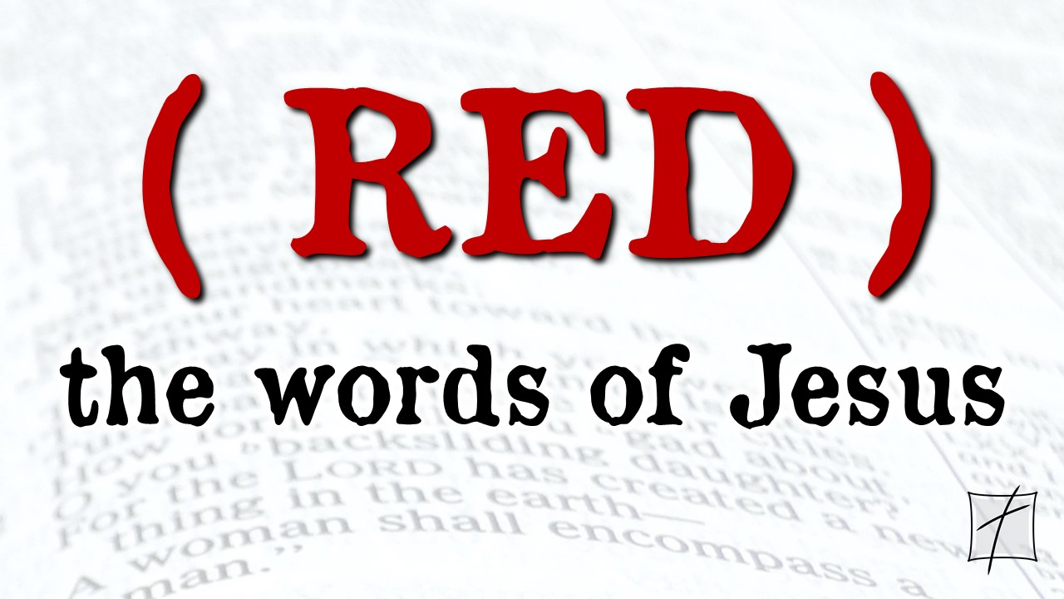
September 27, 2020
Pastor Joseph Britain

Now it happened that while the crowd was pressing around Him and listening to the word of God, He (Jesus) was standing by the lake of Gennesaret; and He saw two boats lying at the edge of the lake; but the fishermen had gotten out of them and were washing their nets. And He got into one of the boats, which was Simon’s, and asked him to put out a little way from the land. And He sat down and began teaching the people from the boat. When He had finished speaking, He said to Simon, “Put out into the deep water and let down your nets for a catch.” Simon answered and said, “Master, we worked hard all night and caught nothing, but I will do as You say and let down the nets.” When they had done this, they enclosed a great quantity of fish, and their nets began to break; so they signaled to their partners in the other boat for them to come and help them. And they came and filled both of the boats, so that they began to sink. But when Simon Peter saw that, he fell down at Jesus’ feet, saying, “Go away from me Lord, for I am a sinful man!” For amazement had seized him and all his companions because of the catch of fish which they had taken; and so also were James and John, sons of Zebedee, who were partners with Simon. And Jesus said to Simon, “Do not fear, from now on you will be catching men.” When they had brought their boats to land, they left everything and followed Him. (Luke 5:1-11)

And Jesus said to them, “Follow Me, and I will make you become fishers of men.”
(Mark 1:17)

The __________________ my sinful past makes
But when Simon Peter saw that, he fell down at Jesus’ feet, saying, “Go away from me Lord, for I am a sinful man!” (Luke 5:8)

And Jesus said to them, “Follow Me, and I will make you become fishers of men.”
(Mark 1:17)

When I try to talk to Jesus about my past
He always starts talking about my future

As far as the east is from the west, so far has He removed our transgressions from us. (Ps 103:12)

We do the __________________
He does the ________-________________
And Jesus said to them, “Follow Me, and I will make you become fishers of men.”
(Mark 1:17)

The thing standing ______________ us
Jesus said to him, “If you wish to be complete, go and sell your possessions and give to the poor, and you will have treasure in heaven; and come, follow Me.” But when the young man heard this statement, he went away grieving; for he was one who owned much property. (Matt 19:21-22)

“Follow Me” is free, but it costs _______________
And He was saying to them all, “If anyone wishes to come after Me, he must deny himself, and take up his cross daily and follow Me.” (Luke 9:23)

Following from a distance = _______________
But Peter was following Him at a distance as far as the courtyard of the high priest, and entered in, and sat down with the officers to see the outcome. (Matt 26:58)

The __________ still stands
So Jesus said to them, “Children, you do not have any fish, do you?” They answered Him, “No.” And He said to them, “Cast the net on the right-hand side of the boat and you will find a catch.” So they cast, and then they were not able to haul it in because of the great number of fish. (John 21:5-6)

All scripture is from the New American Standard Version unless otherwise noted

